**Status Report**

Syed Thahirr Shahid

N01232400

Lab assignment 1

Testing

1a

Modified the commandserver3.c file and created the stub routines and tested it and it worked. I had the server and client connection and when I entered the command it called the stub function and it returned “This is in construction” because I had it return that during this process, I knew that this was just a skeleton of the program.

1g

- At this point I have created and implemented the functions. The program works but it is still a little buggy (I found the solution to this while doing question 3).

This is the copy that I saved when I finished question 1 and this is how the testing went.

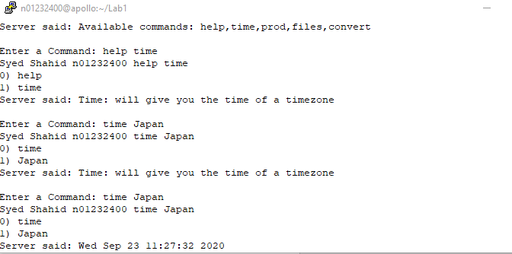

2b

Status update I implement the convert function. I created a separate file and called it syedlocalserver where this will communicate with the my syedServer file with the socket to return the result of the convert function.

Screenshot:

Client:

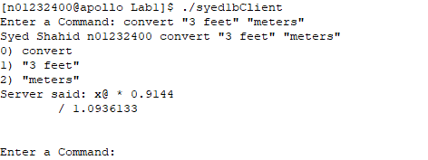

localserverfile:

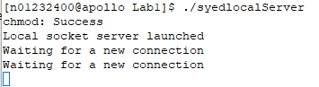

So, the Client communicated with the server, then when the command convert was typed the Server file successfully communicated with the localserverpipe file and returned the converted value.

There were a few small bugs that I came across, where the pipe still had remaining material (this is fixed later on in question 3).

3d

- Question 3 gave a little bit of a hard time in the beginning because as I separated my program into three the stubs, implemented function and the main program. These programs weren’t compiling properly said “ Cmd struct is undefined “ . So, I spent hours trying to figure it out then finally I looked carefully of the demo provided and it uses the alternate declaration method for the cmd method and help parallel data structure. So, I tried the alternate way and it worked. Everything compiled and I tested the program. First running the program, and testing the command, it returned the message saying that “this is from the main program”, then in another terminal. I sent a -SIGHUP signal and so it read from the config file and changed the routines to the stub.so routines. This is how it went:

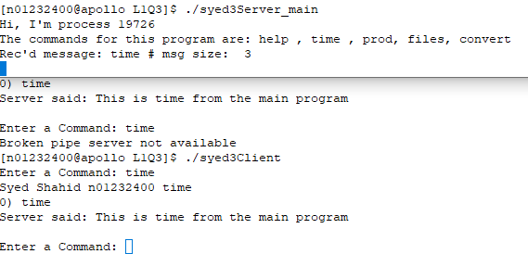



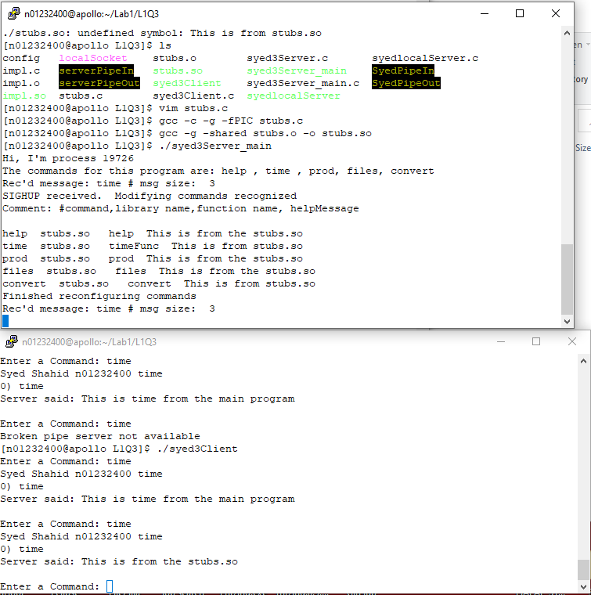

Testing where config file is replaced with the 2nd config file during runtime. This is the whole point of this lab to see if we can dynamically change during runtime

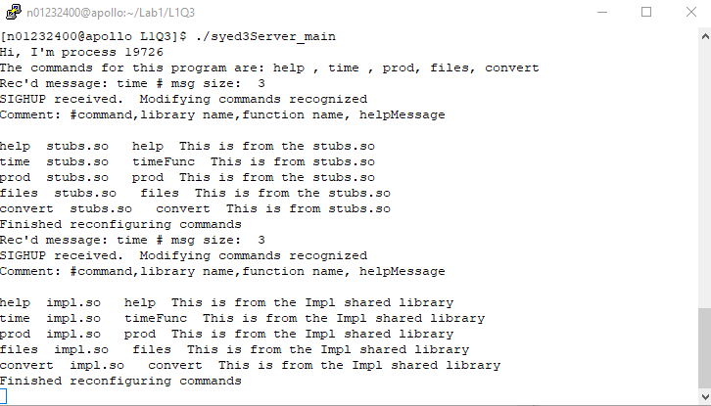

I sent a another sighup signal, So it successfully changed and is now using the implemented function library.

ScreenShots of working implemented functions:

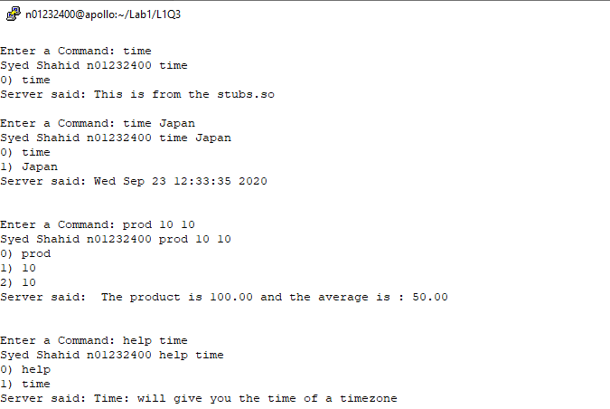

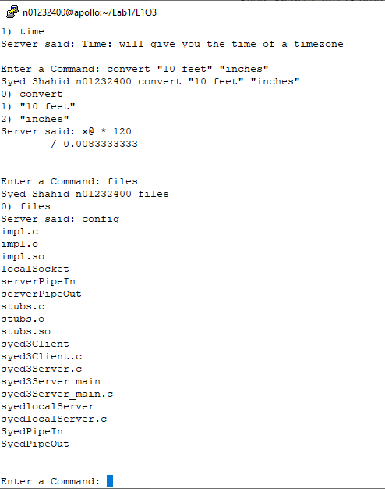

All in all this program works Completely fine and made me really happy that it did!

Earlier in the program I was getting a lot of errors. One: the prod function returned a big number (I fixed this by setting the variables to static so it could store the value and return it. This created another problem of the value just kept adding up. So I had to use the memset function in my variables so that it is completely empty and would return the correct results. Two: while using the files command the result stored in the pipe would not completely display and would have a bad pipe. It took time but eventually figured out that I had to change the incoming msg [] size in the client file. It was 100 previously.